W07

project_lecturer

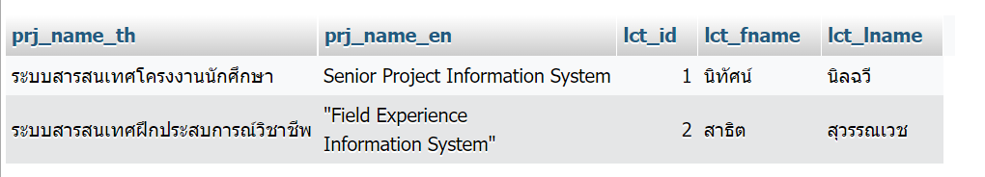

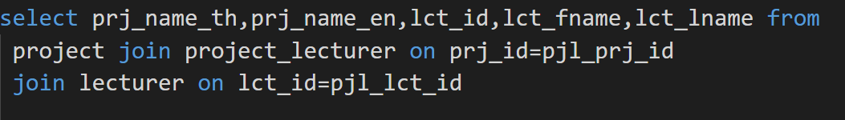

project_progress

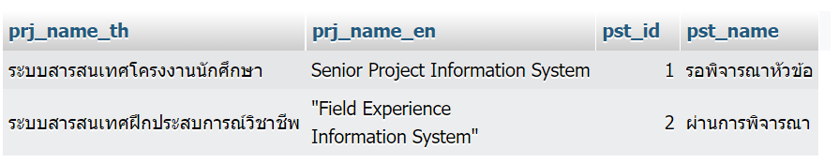

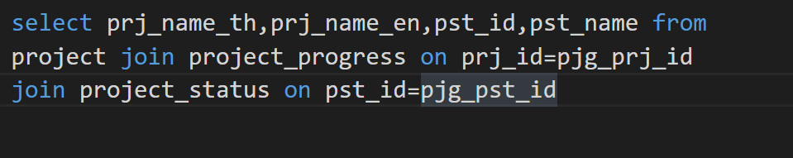

project_student

